Application Topology
Client Server Applications
2 tier 3 tier n tier
XA Arch(SOA)

J2EE
1.Servlet
2.JSp---------------3 types of Programming in J2EE
3.EJB
Open Source J2EE technologies
1.struts
2.Spring
3.Hibernate

3 types of Application
Servlet or JSP or Servlet +JSP= Web Application
EJB= Ejb Application
Servlet or JSP + EJB + WebServices(optional)= Web based Enterprise Application

-------------------------------------------------------------------------------------------------------------
2 forms(format)
1.Exploded Format
the total application will be in a form of Files and Folders

2.Archieve format
Compressed format
-------------------------------------------------------------------------------------------------------------
1. Exploded Format(file and folders)
Technology used for developing the web applications:
GUI---Html,css,javascript,xml,JSP
Middleware---Servlet or JSP
Backend----Database
Web Application—Server independent
Exploded Format of Web Application
ICICI(RootFolder)
|______________*.html(login.html,shoppingcart.html)
|______________*.jsp
|______________css(folder)
| |_________________*.css
|_______________images(folder)
| |______________*.jpg
|_______________WEB-INF(folder)
|______________web.xml(deployment descriptor)
|______________jboss-web.xml(optional))
|______________context.xml(optional))
|_______classes(folder)
|_____*.class(login.class shoppingcart.class)

Exploded Format of EJB Application
EJB Application are Server Dependent
1 EJB Application= 1 type of EJB bean + RMI + JNDI

NBO(RootFolder)
|
|_________*.class------------any type java client class to receiver input for ejb app
|_________Homeinterface.class-------RMI Class
|________remoteinterface.class-----RMI Class
|________ejbbean.class-----------EJB Class
|____________________META-INF(folder)
|_______________ejb-jar.xml(vendor independent deployment descriptor)
|_______jboss.xml(vendor dependent deployment descriptor -optional)

Exploded format of web based Enterprise Application
Webapplication + Ejbapplication + webservcies(Optional)
ICICI(RootFolder)
|______________*.html(login.html,shoppingcart.html)
|______________*.jsp
|______________css(folder)
| |_________________*.css
|_______________images(folder)
| |______________*.jpg
|_______________WEB-INF(folder)
| |______________web.xml(deployment descriptor)
|_______________classes(folder)
| |___________*.class(compiled Java classes)
| |____________Homeinterface.class
| |____________remoteinterface.class
| |____________ejbbean.class
| |__________META-INF(folder)
| |_______ejb-jar.xml(vendor independent deployment descriptor)
|_______application.xml(vendor independent deployment descriptor)
|_______jboss-app.xml(vendor dependent deployment descriptor- optional)
|_______jboss.xml(vendor dependent deployment descriptor- optional)

|____lib(folder)
|___________*.jar
|___servcies(folder)
|_____*.wsdl
-------------------------------------------------------------------------------------------------------------
2.Archieve Format(Compressed Format)

webapplication------------*.war (web archieve files)
ejb application--------------*.jar(java archieve files)
web based Enterprise Application------*.ear (*.war +*.jar) enterprise archive files
.sar(webservice files)
.rar
-------------------------------------------------------------------------------------------------------------

3 ways to peform Application deployment
1.AdminConsole (GUI Console)
2.Auto Deployment -Hot Deployment
3.Console-Commandaline Deployment

Auto Deployment -Hot Deployment
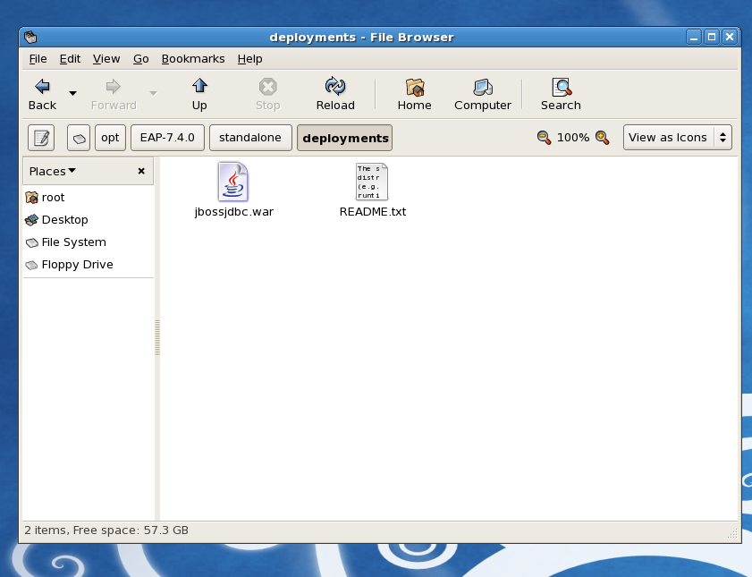

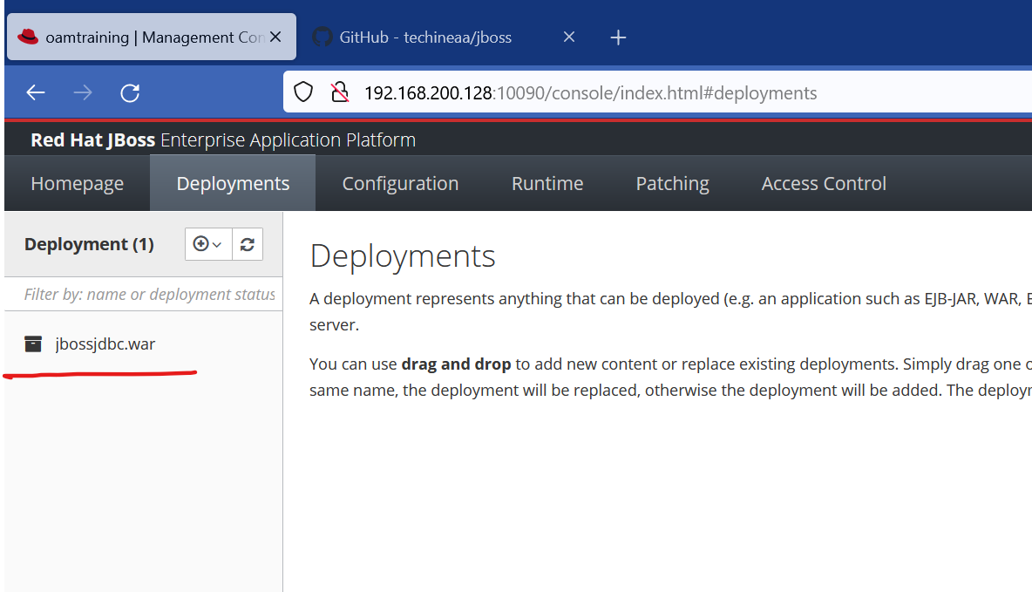

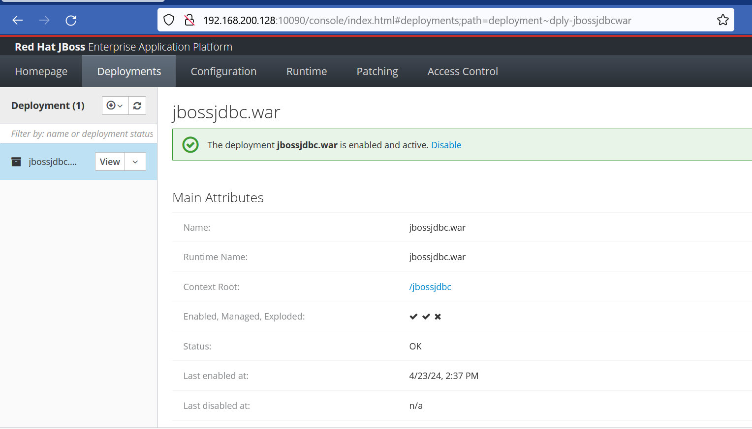

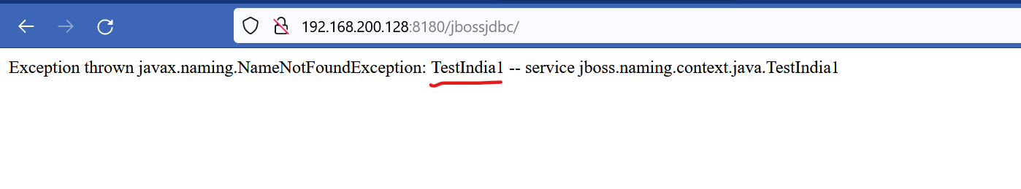

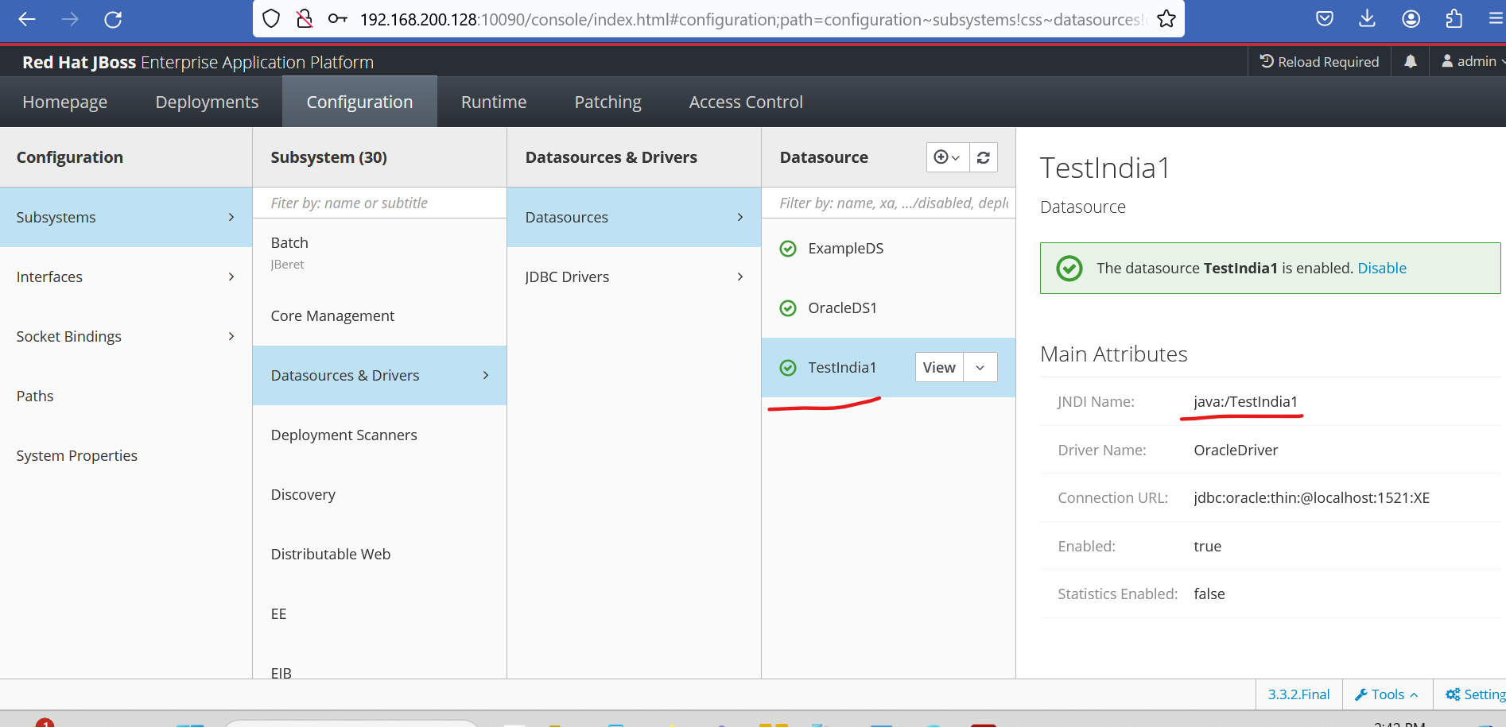

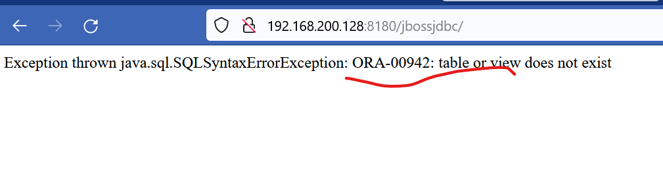

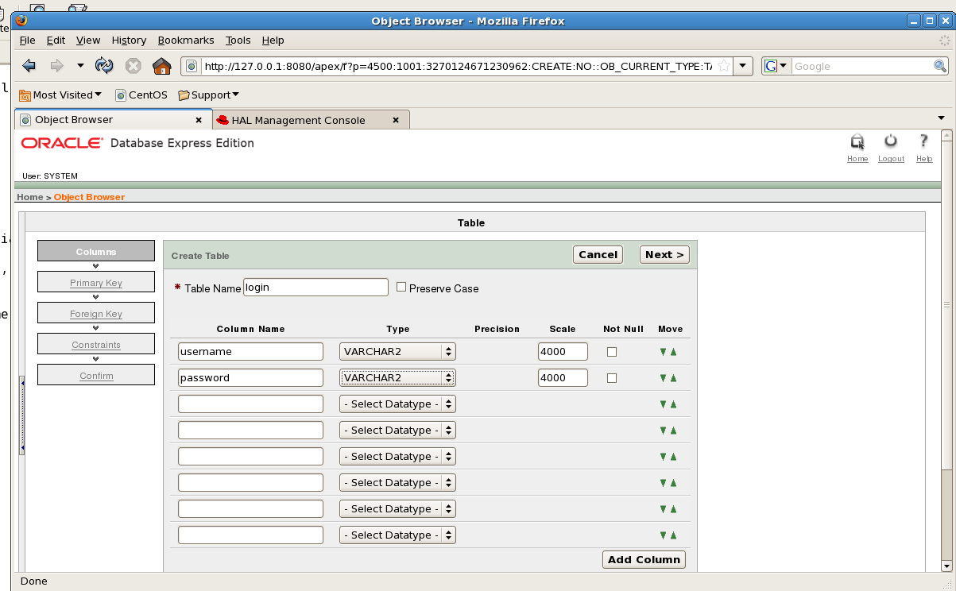

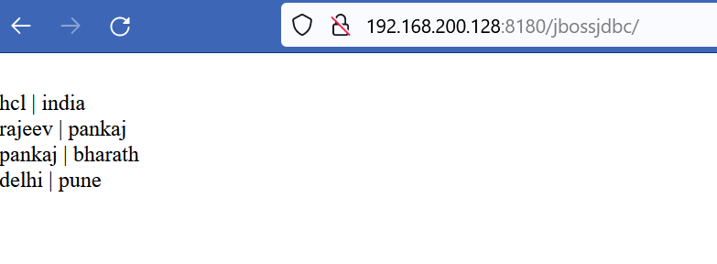

Deployment using jboss admin console
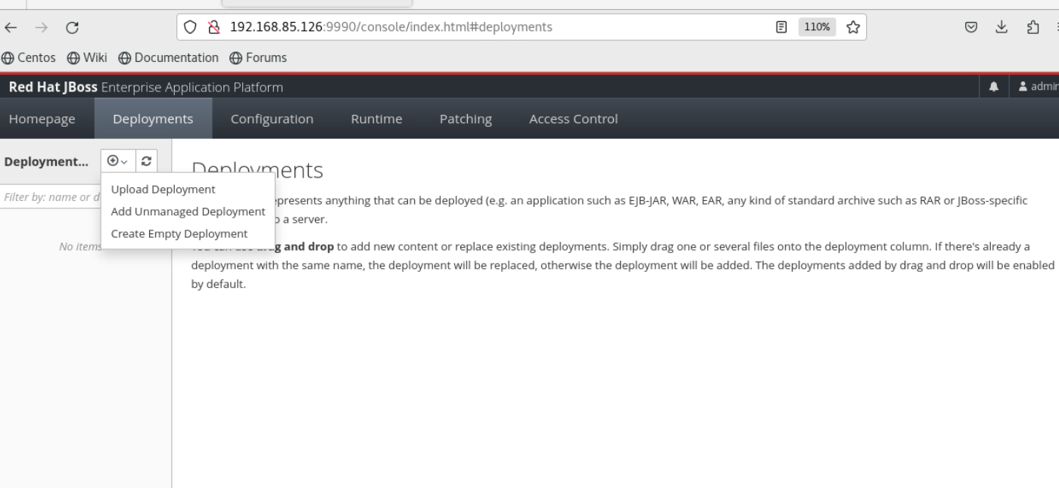

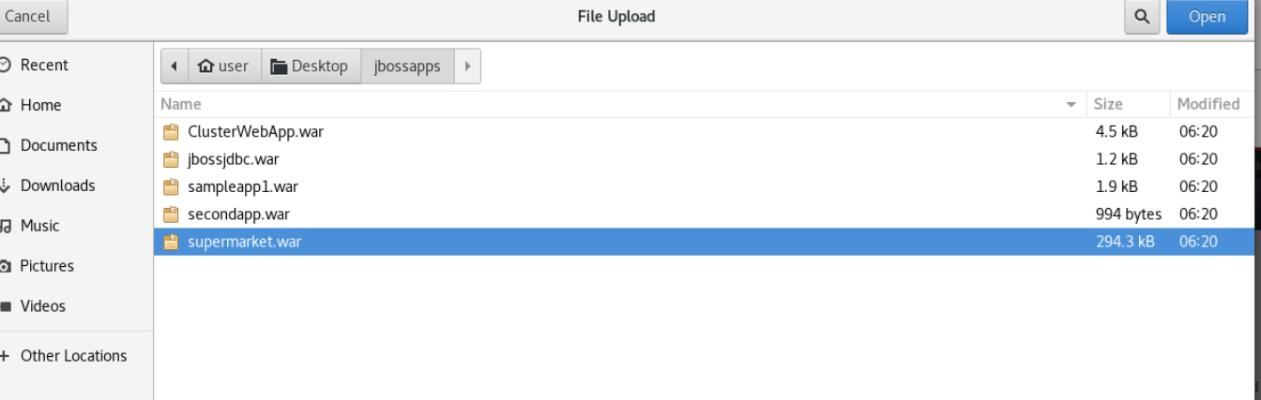

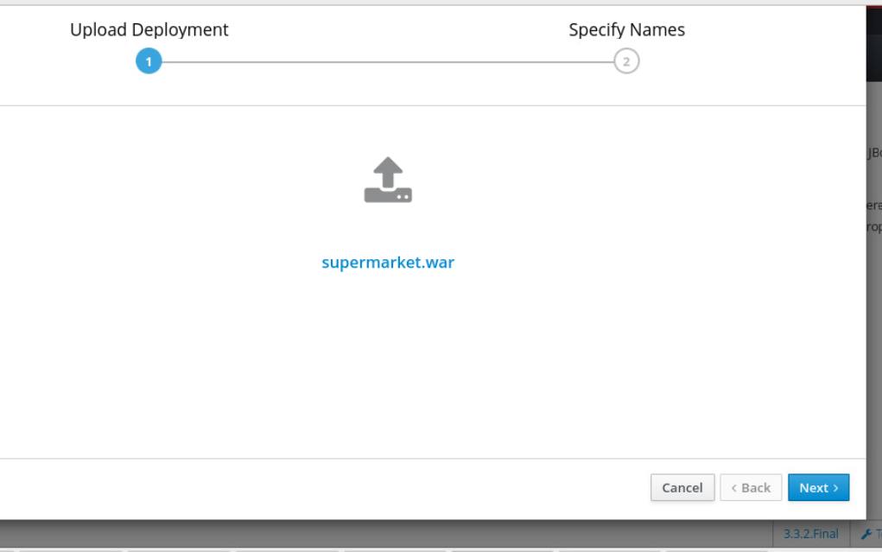

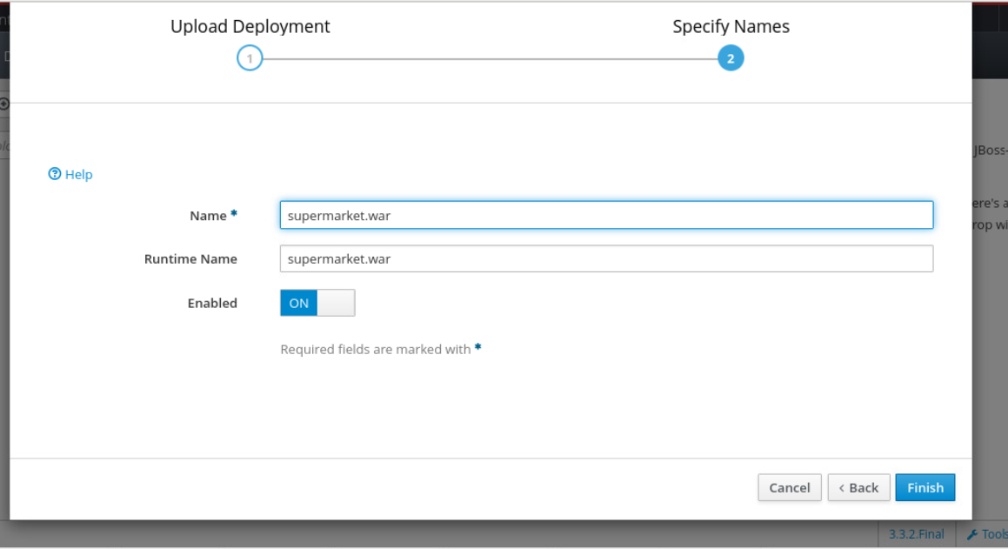

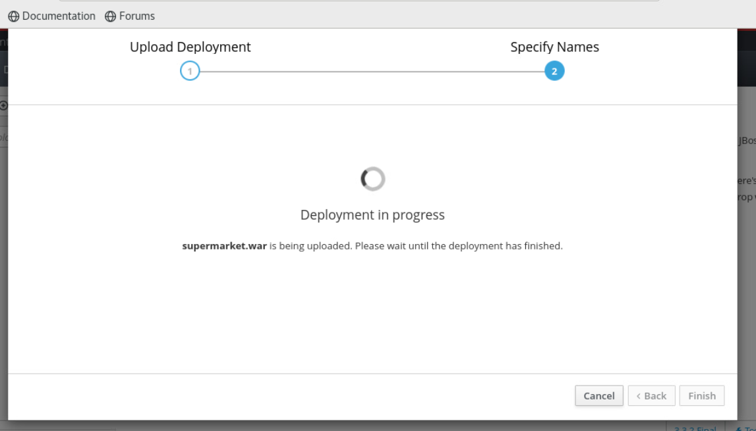
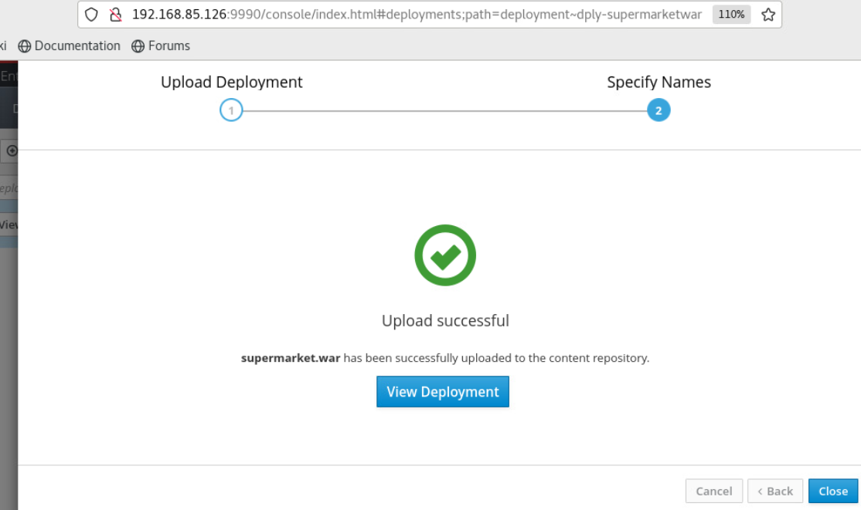
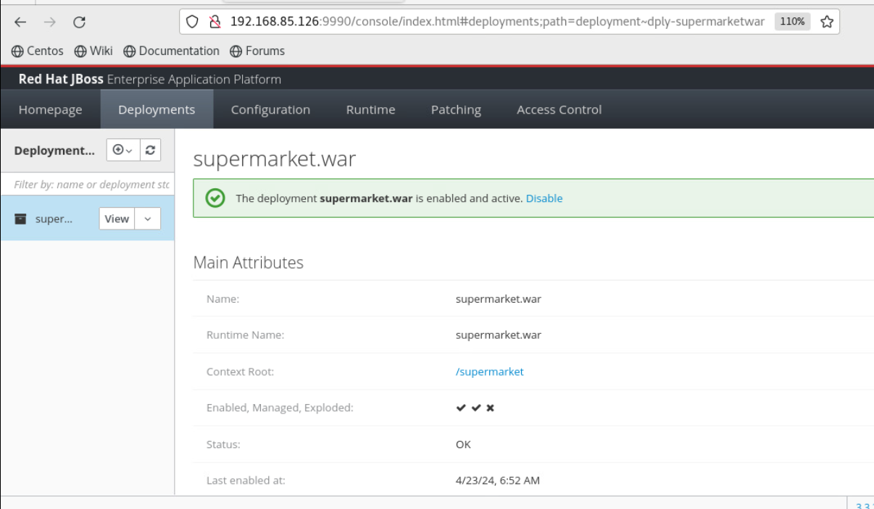

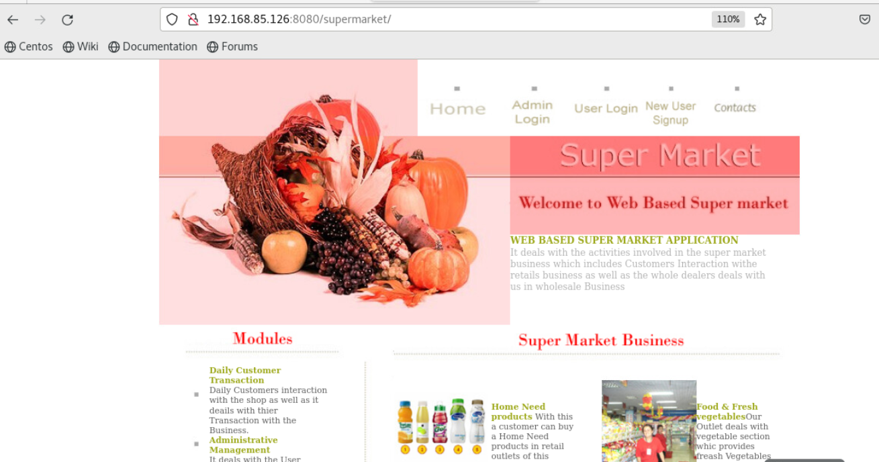

How to stop the deployment
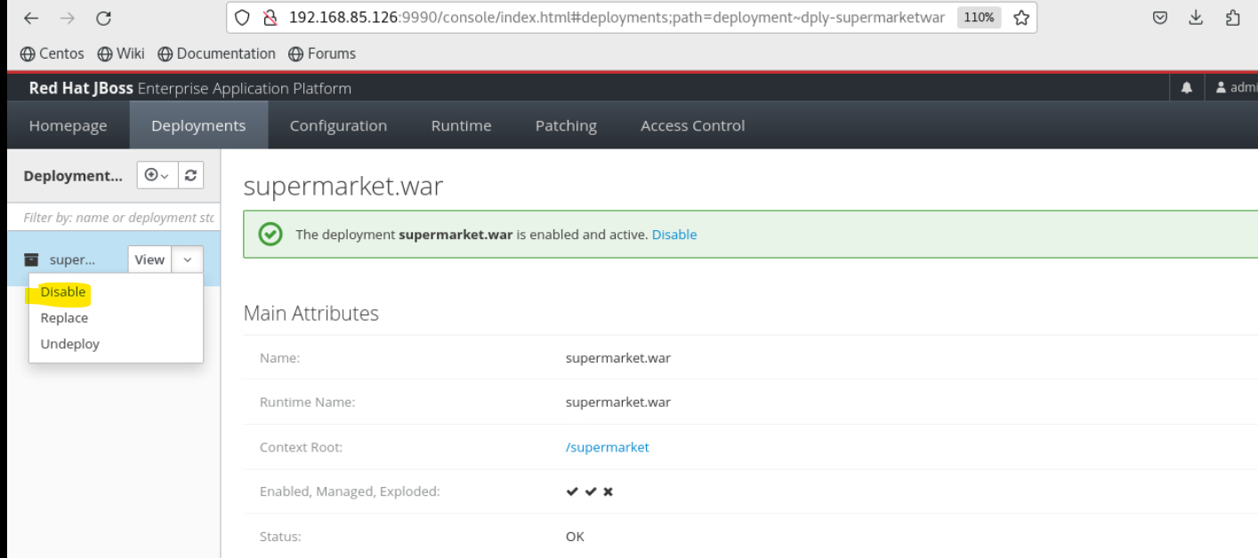

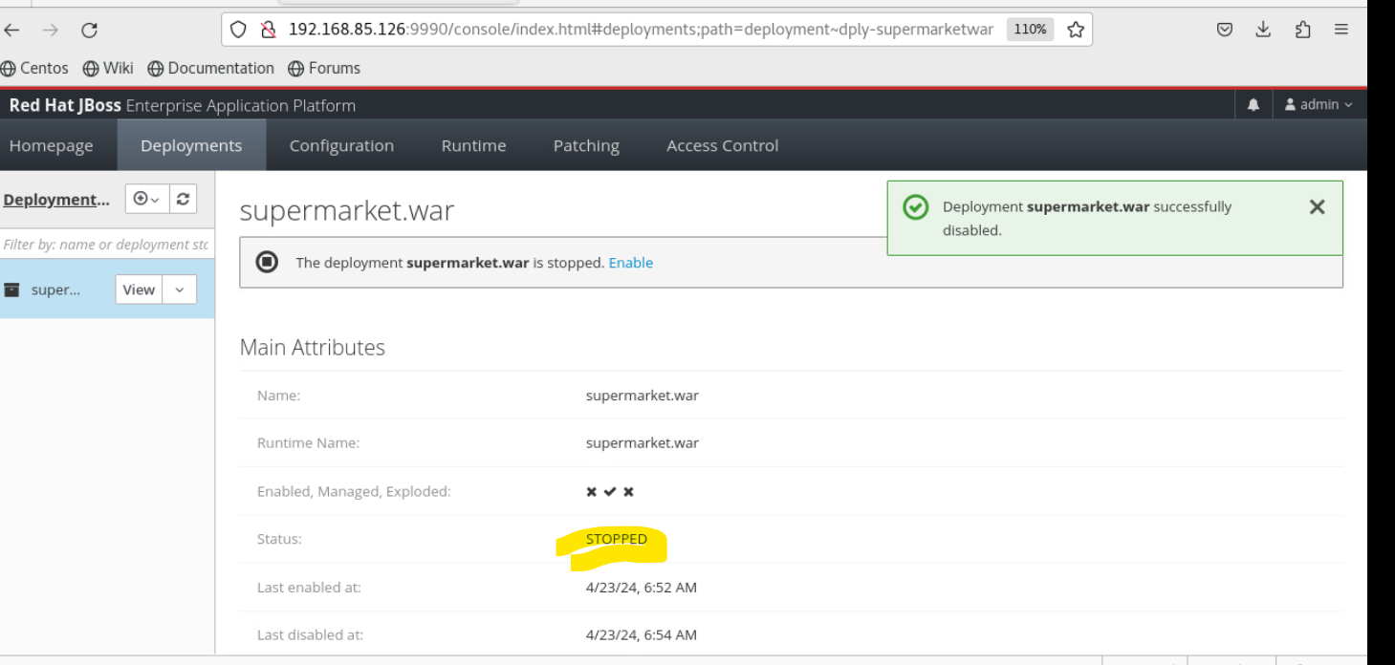

Deployment Stopped

